**No: 10/2/12524** 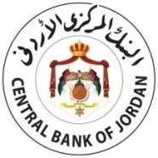

**Date: 10 Muharram 1432 Hijri**

**Corresponding to: 16 December 2010**

**Instructions for the Minimum Capital of Licensed Banks**

**No. (52/2010)**

In accordance with the provisions of Articles (8) and (12) of Banking Law No. (28) of 2000 and amendments thereto, and in line with the Central Bank of Jordan’s keenness to enhance the financial solvency of banks and their ability to face the banking business risk, I hereby decide the following:

1. Increase banks’ minimum capital to become (100) million Jordanian dinars for Jordanian banks and (50) million Jordanian dinars for foreign banks’ branches.
2. Banks whose capital is less than the minimum referred to in paragraph (First) above shall reach this amount before the end of 2011, and submit to the Central Bank the proposed mechanism for increasing the capital not later than the end of the first quarter of 2011.
3. These instructions shall come into force as of date.

**Governor**

**Fares Abdul Hamid Sharaf**