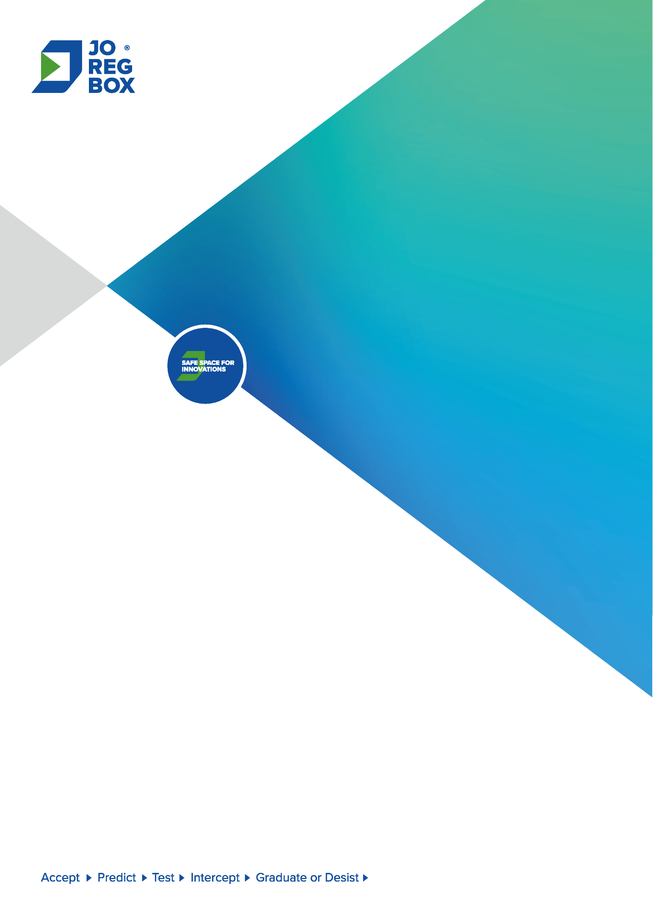

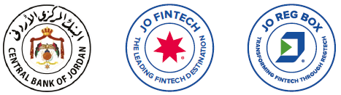

Regulatory Sandbox Application

# Preamble

The Regulatory Sandbox for Financial Technology and Innovation (JoRegBox) represents a pioneering initiative that reflects the commitment of the Central Bank of Jordan (CBJ) to provide a conducive environment for the advancement of Financial Technology (Fintech) and innovation within the Jordanian financial and banking sector. The Regulatory Sandbox serves as an effective tool offered by the CBJ to innovators and business pioneers, aiming to support innovative digital financial solutions, enhance the efficiency of financial services, improve the financial consumer experience, and contribute to support financial inclusion levels in the Kingdom".

JoRegBox serves as a real experimental regulatory environment, secure and subject to the supervision and oversight of the Central Bank of Jordan. The JoRegBox enables business pioneers and innovators to test innovative financial products, services, and business models using digital solutions developed based on modern technology with real customers, following a risk-based approach and within clearly defined standards and controls, ensuring maximum transparency.

Within this regulatory environment, innovative digital financial solutions undergo a comprehensive testing and evaluation process without directly complying with certain regulatory requirements specified under applicable legislation during their stay within the regulatory sandbox. This approach actively promotes innovation in the use of fintech and accelerates the entry-to-market phase.

# General Instructions

To be able to fill out an application to join the Regulatory Sandbox of Central Bank of Jordan (JoRegBox), the applicant must take into consideration the following:

1. This application form is considered one of the primary documents that CBJ relay on to determine the applicant’s eligibility to participate in the JoRegBox.
2. In case of the inability to fill certain items of the application form, please clearly indicate that by typing the expression ‘N/A’, with an explanation of the reason in the notes field.
3. The applicant should fill the application form electronically, and submit the completed application form and all supporting documents to the following email address ([jo-fintech@cbj.gov.jo](mailto:jo-fintech@cbj.gov.jo)). Incomplete applications will not be considered. If the applicant is unable to submit any required supporting documents with this application, an explanation of the reason should be provided within the note field.
4. CBJ informs the applicant of the receipt of his application through the contact officer and the e-mail specified by the applicant within a period not exceeding two business days from the date of sending it to the CBJ.
5. CBJ may request any data, information, or other documents that it deems necessary to study the submitted application.
6. CBJ will inform the applicant through the contact officer and the specified email provided by the applicant of the result of the study of his application within a maximum period of (60) working days, extendable for an additional (30) working days. This period is calculated from the date of notifying the applicant of the receipt of his application.
7. Providing false or misleading information in the application may result in the refusal or the suspension of the application immediately if this is discovered at any stage of the stages of dealing with the application, i.e. from the application stage all the way to the graduation stage.
8. The application will be assessed according to the eligibility criteria and conditions specified in the Regulatory Sandbox for Fintech and Innovation Framework published on the CBJ website. Accordingly, the applicant must review this framework and read it carefully to ensure that all requirements are met.
9. In case of any inquiries during the application filling stage, the applicant can contact the Financial Technology and Innovation Division at the Central Bank of Jordan through the email [Jo-fintech@cbj.gov.jo](mailto:Jo-fintech@cbj.gov.jo) or by phone at (+96264630301) extension (2655), (1510), or (1708).

# Declaration and Pledge

I, , holder of National ID number , acting as an authorized representative of the entity owning the Innovative Digital Financial Solution, hereby submit an application to the Central Bank of Jordan to join the Regulatory Sandbox framework for Financial Technology and Innovation (JoRegBox), declare that I have read and understood the regulatory framework of the JoRegBox. I further pledge that all the data, information, and documents attached to the application are complete, accurate, and true, and there are no essential data, information, or documents that have not been submitted to the Central Bank of Jordan.

I also pledge to inform the Central Bank of Jordan in the event of any modification to any of the data, information, or documents submitted at any time during the entry and participation into the JoRegBox.

And I pledge, under the penalty of legal accountability, to comply with all procedures and requirements specified by the Central Bank of Jordan when providing financial services through the Innovative Digital Financial Solution subject to this application during its testing period in the JoRegBox. I also commit to maintain the confidentiality of the data and not to provide financial services in an unlawful manner.

Authorized representative name:

Day: Dated:

The applying entity:

# First: Applicant Information

|  |  |
| --- | --- |
|  | Applicant Name |
|  | Applicant Residency |
|  | Applicant National/ID number |
| Licensed financial institutions and banks regulated and supervised by the CBJ.  A startup company developing new financial products, services, or technologies within the Kingdom.  A startup company developing new financial products, services, or technologies outside the Kingdom.  Fintech company within the Kingdom.  Fintech company outside the Kingdom.  University or research institution.  Ministry or government agency or public institution.  Other entity, please specify: | Business Domain |
|  | Contact officer Name |
|  | Contact officer phone number |
|  | Contact officer email |
|  | Applicant entity website URL –if exists- |
|  | Applicant entity email |
|  | Applicant entity address |
|  | Brief description of the Applicant entity* |

* *Please provide a description of the entity's activities in the field of financial technology and innovation, whether within or outside the Kingdom. Additionally, include details about all licenses and permits obtained by the entity to carry out its activities, and any partnerships the entity intends to establish for the purpose of implementing the Innovative Digital Financial Solution subject to this application during its testing phase in the Regulatory Sandbox for Financial Technology and Innovation (JoRegBox).*

In case the applying entity or any of its shareholders owning (10%) or more of its ownership has been subject to any legal proceedings in the past five years, please provide details. Financial institutions and banks licensed by the Central Bank of Jordan and under its supervision are exempt from this requirement

|  |
| --- |
|  |

**Attachments:**

The applicant is required to attach the following documents:

* Commercial registration and the articles of association for the Applicant.
* A copy of the identification document and passport for shareholders owning (10%) or more of the entity's ownership, excluding financial institutions and banks licensed by the CBJ and under its supervision.
* A copy of the identification document for the contact officer.

# Second: About the innovative financial solution

|  |  |
| --- | --- |
| 1. Brief Overview of the Innovative Digital Financial Solution Subject to the Application | |
| Provide a brief explanation of your innovative solution here. You can also attach a demonstration presentation or any material that clarify any details about the innovative solution and its business model. | |
| There is no alternative way to reach the central bank.  Testing the innovative solution using a real environment to prove the concept.  Lack of a legislative framework to regulate the innovative solution**.**  The innovative solution conflicts with applicable legislation**.**  Licensing a company to implement the innovative solution is difficult/very expensive.  Other, please specify**:** | 1. What are the reasons for applying to join the regulatory sandbox: |
| A completely new service (Market research or any evidence must be provided proving the absence of similar offerings in Jordan).  Used in a new market (e.g. Introducing the innovative solution in a different sector or a service applied externally, with consideration for its application in Jordan).  Represents an alternative to existing market solutions in terms of elevating efficiency and effectiveness. Please attach a comparison between the key features of the new innovative solution and existing solutions, outlining the differences and the competitive advantage gained.  It adds value to the financial and banking sector.  It utilizes a new technology unlike what is currently available in the market.  It utilizes current, prevalent technologies in Jordan but in a new and different manner.  Addresses a subject related to enhancing the supervisory and regulatory framework, regulatory compliance, or risk reduction.  Other, please specify: | 1. What makes your digital solution innovative and distinctive? |
| Yes  No  If the answer is (Yes), please provide us with the name of the regulatory authority and the results of the examination process that was carried out: | 1. Has your innovative solution been examined by any local or external regulatory authority? |
| Banking business, including Islamic banking business.  Insurance services.  Payment and money transfer services.  Savings, lending and financing services, including alternative financing.  Suptech, Regtech and Risktech.  Digital services supporting financial activities that contribute to supporting the digital transformation process of the financial and banking sector, including services provided by third parties. Please specify: | 1. What financial activity does the innovative solution related to? |
| Yes  No  If the answer is (Yes), please specify these entities/ third parties | 1. Does the innovative solution require cooperation with third parties? |
|  | 1. How does the innovative solution support the financial sector in the Kingdom? |
|  | 1. What added value will your innovative solution provide to the local market? |
|  | 1. What are the challenges and obstacles that the innovative solution contributes to solving? |
|  | 1. What technology have been used in the innovative solution? |

# Third: Innovative solution readiness for testing in the JoRegBox environment.

|  |  |
| --- | --- |
|  | 1. How prepared is the innovative solution for testing in a regulatory sandbox environment?  Please support your answer with evidence of:   * The innovative solution was technically tested with a third party (the name of the party and the results of the tests to be attached) * Having developed plans and sufficient guarantees to protect customers and deal with risks |
| Yes  No  If no, explain how the costs of testing the innovative solution will be financed: | 2. Do you have the necessary funding to support the execution of the innovative solution in the regulatory sandbox? |
|  | 3. What is the total number of customers expected to be included in the testing process for the innovative solution? |

# Fourth: The expected benefits and potential risks

|  |  |
| --- | --- |
| 1. The desired benefits of the innovative solution | |
| Improving and enhancing access to financial services  Enhancing competitiveness  Improving the level of efficiency of financial services  Increase the workforce  Market expansion  Improve customer experience.  Other, please add: | * 1. What are the expected benefits of the innovative solution? |
|  | * 1. What are the targeted customer categories for the innovative solution? |
|  | * 1. How does the innovative solution provide benefits to customers, whether directly or indirectly? |
| 1. Potential risks for the innovative solution. | |
| Legal Risk  Operational risk  Compliance risk  Reputation risk  Cyber security risk  ML/FT Risk  Financial consumer protection risk  Other, please specify: | * 1. Identify the key potential risks associated with the innovative solution |
|  | * 1. Explain how you plan to mitigate the severity of these risks and make them acceptable? |
| 1. Measures taken to mitigate potential risks | |
|  | * 1. What guarantees do you intend to provide? |
|  | * 1. What measures are in place to protect the confidentiality and integrity of data? |
|  | * 1. What procedures and mechanisms are in place to handle customer complaints? |
|  | * 1. What procedures are followed to identify customers and ensure that none of them is listed in international and local sanction lists? |
|  | * 1. What thresholds will be imposed on transaction size during the testing phase? |

# Fifthly: Testing Phase

|  |  |
| --- | --- |
| 1. What are the use cases and scenarios that will be examined? | |
| 1-3 months  3-6 months  More than 6 months | 1. What is the approximate timeframe to complete the testing process? |
| please provide justification If there a need for more than 6 months | |
| Yes  No  If the answer is yes, please attach it. | 1. Has a draft contract been prepared for signing with volunteer customers, including disclosure to customers about the potential risks versus benefits of participating in the innovation solution testing process? |
| 1. What are the Key Performance Indicators (KPIs) that will be used to determine the success of the test? | |
| 1. What are the criteria for verifying the KPIs that will be used to determine the success of the test? | |

# Sixth: Exit Plan

|  |  |
| --- | --- |
| 1. What steps will be taken if the testing of the innovative solution succeeds, and the desired goals are achieved, leading to its graduation from the JoRegBox? | |
| 1. . What are the main stages of the exit plan from the JoRegBox? | |
| 1. What is the proposed contingency exit plan if the testing is terminated prematurely or during the testing phase? How will the test be terminated without exposing customers to risk or harm? | |
| Yes  No | 1. Is there an exit plan with partners in case any of them withdraws? |
| Yes  No | 1. Is there a plan for market expansion? |